

IDENTIFICATION OF SL GENE CANDIDATES SPECIFIC FOR PARTICULAR GENETIC ABERRATIONS THROUGH A MODIFIED BIOINFORMATIC SCREEN

FIRST YEAR REPORT

AHMED OMER

(Supervisors – G Strathdee, D Hicks, E. Schwalbe)

Table of Contents
1 Introduction. 1
1.1 Introduction to Synthetic Lethality 1
1.2 DNA methylation 2
1.3 Synthetic lethality and oncogene and non-oncogene addiction 5
1.4 Introduction to Medulloblastoma 6
1.4.1 Genetic changes in medulloblastoma 6
1.4.2 Already existing treatment methods for MB based on subgroup genetic changes. 7
2 Methods. 8
2.1 Introduction to bioinformatics pipeline 8
2.2 Project Aims 11
2.2.1 Mitigations. 14
2.2.2 Limitations of my project. 14
3 Future work Gantt Chart. 14
4 References. 16

Figure 1. Outline of synthetic lethality. 1
Figure 2. Transcriptional repression caused by DNA methylation. 2
Figure 3. Two types of DNA methylation. 3
Figure 4. Patterns of DNA methylation within normal and cancer cells. 4
Figure 5. How differential methylation patterns at SL genes are selected for in cancer. 4
Figure 6 Schematic representation of the effect of cells undergoing oncogene addiction and non-oncogene addiction.. 5
Figure 7 Comparison of the various medulloblastoma subgroups. 7
Figure 8 Overall survival among SHH subtypes of MB.. 8
Figure 9 Summary of MB Grp3/4 molecular subtypes. 8
Figure 10 Flow diagram depicting the general bioinformatic pipeline that is used to identify the group of interest. 10
Figure 11. CRISPR-based approach used for functional analysis of the identified SL candidates. 13

Introduction.

Introduction to Synthetic Lethality
Synthetic lethal (SL) genes are genes that interact, maintaining the intactness of the cell [1–3]. If mutations occur in both SL genes this leads to cell death, while the cell can survive if either one of the SL genes are mutated, or if the pathway is disrupted by mutations in its components (figure 1) [1–3]. SL was first reported by Bridges CB when he observed this phenomenon in fruit flies [3]. The SL concept was subsequently further advanced by Dobzhansky, whom also coined the term [2]. Sometimes one or both of members of an SL pairs can be a specific cellular pathway, rather than a single gene[1, 4]. This is because the SL pair is not only comprised of two individual genes, because they are not the sole participants pathway that forms a member of an SL pair, as other genes also take part [1, 4]. However, if only one gene takes part in a cellular process, such as protein phosphorylation or acetylation, then this particular gene can make up a member of the SL pair [1, 4].
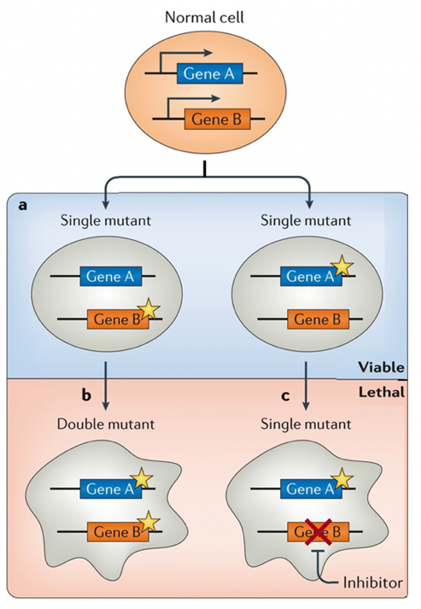

Figure 1. Outline of synthetic lethality. When the protein products of either gene A or B alone get inhibited or lost in an SL pair of genes, the cell will continue to survive (part a). Synthetic lethality will be resulted in this case when there is a mutation (part b) or pharmacological inhibition (part c) of the other gene (in this case gene B) of the SL pair, given that gene A in SL pair is already mutated or inhibited. The star shape represents a mutation. The red crosses represent pharmacological inhibition. Cells with random shapes represent inviable cells, while oval-shaped cells represent viable cells. This figure is adapted from figure 1 in O'Neil et al. 2017 [1].
Recently SL genes have been investigated for their potential use as therapeutic targets for cancer therapy (figure 1) [1]. This is because it can be difficult to target overexpressed oncogenes or downregulated TSG genes, which are main causes of cancer progression [5–9]. Targeting SL provides a remarkable primary advantage of achieving a very high degree of specificity, providing the target will only be lethal in cancer cells [10]. The second advantage would be the ability of targeting of TSG or some oncogenes that are traditionally hard to target, such as transcription factors [10, 11]. The concept of dosage suppression and synthetic dosage lethality, that were initially integrated the concept of SL in the 21st century by Vivien Measday has further strengthened the reasoning for SL use as a potential target in cancer [12]. Dosage suppression and SL concepts were based on the fact that lethal mutation of one gene can be rescued by overproduction of another gene [12]. The First synthetic lethality targeting therapy was recently FDA approved in 2017, even though SL-based treatment was first been conceptualized first in 1997 [13, 14]. This targeting therapy was based on BRCA1/2 and PARP SL interaction, which can be targeted [15]. BRCA1/2 is essential for double-strand break repair, while PARP is essential for single-strand break repair [15]. Both of these processes can compromise for DNA repair (and therefore cell survival), if one of the processes carried out by each gene, is inhibited or absent [15]. The SL interaction between BRCA1/2 and PARP function as proof of principle SL based therapies can be effective in cancer treatment [15]. My lab has previously focused on identifying SL gene candidates specific for subgroups of cancers, such as medulloblastoma and neuroblastoma, which were called SSVs or Subtype-Specific Vulnerability genes [1, 4]. My lab also identified SL gene candidates specific for a disease as a whole (called DSDGs or disease-specific dependency genes) [1, 4]. This project aims to identify SL gene candidates based on specific genetic changes, rather than being subtype-specific or Disease-specific [1, 4]. Therefore, targeting these SL gene candidates can also be possibly applied to other cancers with the same specific genetic defect [1, 4].

DNA methylation
The formation of 5-methyl-cytosine (5mC) is catalysed by DNMTs (DNA methyltransferases). While DNA methylation on its own often has minimal impact on gene expression, this leads to binding of large protein complexes, such as NuRD complex and Sin3a which cause alterations in chromatin structure and gene inactivation (figure 2) [16–21]. Transcriptional repression is caused by chromatin condensation and especially by aggregation of these large complexes at gene promoters, ultimately causing chromatin compaction and so blocking transcription factors from accessing gene promoters of transcription factors [16–21].

Figure 2. Transcriptional repression caused by DNA methylation. (a) shows an active state of chromatin, that is characterized by highly acetylated histone tails and unmethylated DNA, which enables gene transcription to take place. (b) DNA methyltransferases (DNTM1, -3a, and -3b) cause methylation of CpG sites. (c) NuRD and Sin3a complexes bind to methylated DNA due to activity of methyl binding domain proteins (MBD2, MeCP2). The complexes induce chromatin remodelling and histone deacetylation, resulting in condensation of chromatin and transcriptional inactivation. This figure is adapted from Strathdee et al. 2002 [21].
There are four main types of DNMTs. Three of them are directly involved in DNA methylation, these include: DNMT1, DNMT3A and DNMT3B (figure 3) [16, 22]. DNMT3L is another main type of DNMT that acts as a cofactor for DNMT3A and DNMT3B [16, 22]. DNMT1 is involved in maintenance of DNA methyltransferase activity, and allows inheritance of the methylation pattern after replication of the genome [23]. This pattern was initially established on the unmethylated DNA by de novo methyltransferases, like DNMT3A and DNMT3B (figure 3) [24]. Since the CpG site sequence is palindromic, this pattern will be maintained by DNMT1, because it targets hemi-methylated DNA within the proliferating cells [23, 25].

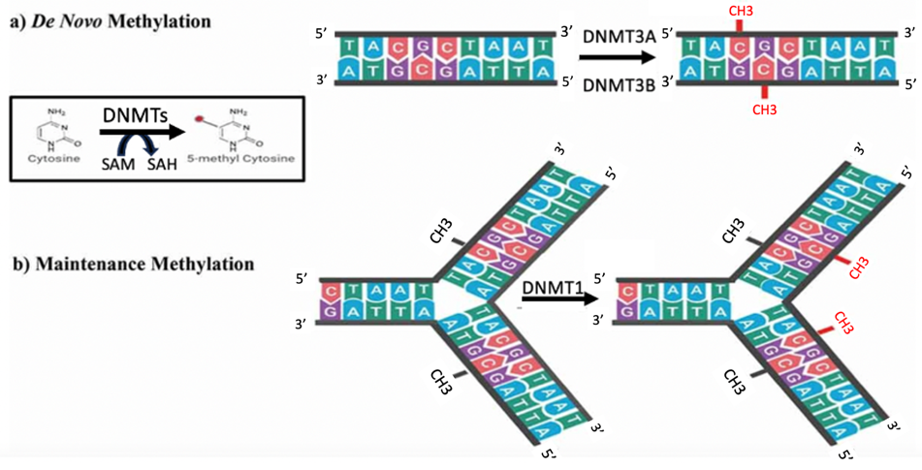
Figure 3. Two types of DNA methylation. As outlined in the little box, 5mC is created by DNMTs by means of transfer of a methyl group from S-Adenosyl Methionine (SAM) to Cytosine, resulting in the creation of 5mC and S-Adenosyl Homocysteine (SAH). DNMT3A and DNMT3B both cause de novo DNA methylation, i.e. methylating DNA that was not methylated before on both strands. While DNMT1 causes maintenance methylation of “hemi-methylated” DNA (i.e. methylated on only one strand). This figure is adapted from figure 2 in Sallam et al. 2022 [26].
About 1% of the human genome consists of CpG sites [27–29], of which about 70% of these CpG sites are methylated in normal cells [29, 30]. CpG Islands, or CGIs are regions within the genome and especially within the promoters of genes [31, 32]. They are usually about 200 bp in length [31, 32]. CGIs have a large proportion of CpG sites, with a GC percentage of about 50% [31, 32]. CGIs also have an observed to expected ratio for number of CpG sites which is about 60% [31, 32]. In normal cells, very few of the CGIs are methylated, numbering around 5% [31–33]. This is because in normal cells there is more global or overall methylation, especially at CpG sites outside of the promoters [31, 32] However, in cancer cells there is more numerous methylations of CpG sites within CpG islands in the promoters of genes (figure 4) [31, 32]. This pattern of differential methylation between normal and cancer cells, enables a selective event (described below) [4, 31, 32].
The stochastic methylation of cytosines on numerous CG sites or on CGIs can lead to a selective process that will contribute to tumorigenesis [4, 34]. 5-methyl-cytosine formation occurs randomly within the genome of cancer cell [4, 31, 32]. Therefore, in the selective process, the tumour will select those cancer cells that do not have significant methylation of promoters of genes that form SL pairs with the initiating genetic mutation [4, 35]. This is because hypomethylated SL genes (or set of genes in a pathway) will work to keep the cell alive (figure 5) [4, 35]. Conversely, in the same cancer type, tumours with cancer cells that have initiating mutations of a different gene or pathway, then the previously identified individual SL gene would not form a synthetic lethal pair anymore with the new initiating mutation [4, 35]. This means that cancer cells undergoing hypermethylation of the gene that was previously identified as being SL, would survive and tumour will propagate (figure 5) [4, 35]. There are several genes in cancer that have become silenced as their promoters are hypermethylated, such as RB, BRCA1, and APC [4, 36, 37]. These genes are involved in several vital pathways essential for tumour suppressive function [36, 37]. Therefore, finding means to specifically targeting these methylation patterns can play essential role here in cancer therapy [4, 36, 37].
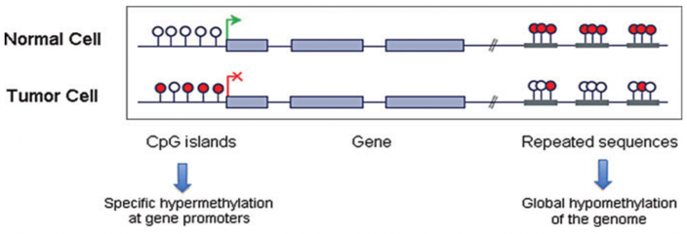
Figure 4. Patterns of DNA methylation within normal and cancer cells. In normal cells: the repeated sequences are generally methylated and therefore there is no chromosomal instability and no activated retrotransposons; The CpG islands in promoters are relatively unmethylated; the CpG island shores (located upstream of promoters) are also unmethylated; and the CpG sites present in gene bodies are frequently methylated [32, 38]. However, in cancer cells: the repeated sequences are often not methylated and therefore causing chromosomal instability and activation of retrotransposons; the CpG islands on gene promoters are often methylated, as well as at the CpG island shores; and lastly the gene body CpG sites are more frequently not methylated [32, 38]. The more frequently occurring promoter CpG island methylation in cancer cells causes transcriptional initiation at several incorrect sites, leading to frame-shift mutation [32, 38, 39]. This figure is adapted from figure 1 in Jueliger et al. 2018 [32].
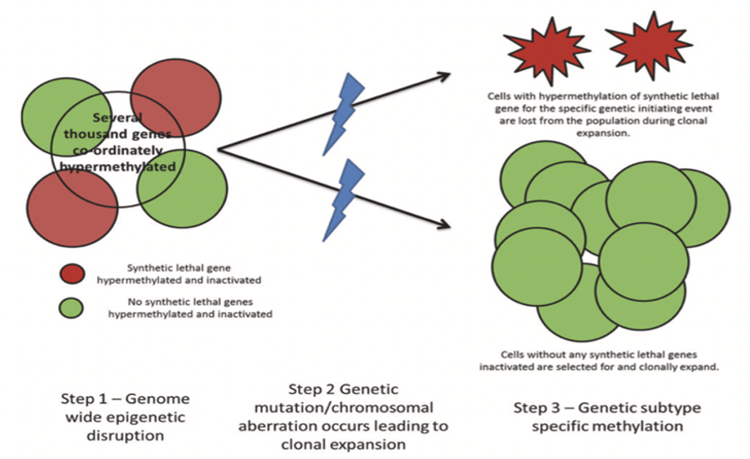
Figure 5. How differential methylation patterns at SL genes are selected for in cancer. Step 1: during tumorigenesis, thousands of CpG islands will be hypermethylated randomly within a cell. Step 2: Clonal expansion occurs caused by a mutation or chromosomal aberration. Step 3: The red cells, by chance, have an SL gene partner for the initiating genetic change randomly hypermethylated. As a result of this the red cells will not survive. The green cells, also by chance, do not have hypermethylation of the same SL genes and thus they do survive. As a result, there is a strong selective pressure to select for low methylation at the SL genes, but only in the presence of the particular genetic mutation with which the genes are synthetically lethal. Conversely, in the same cancer type, tumours with cancer cells that have initiating mutations of a different gene or pathway, then the previously identified individual SL gene would not form a synthetic lethal pair anymore with the new initiating mutation. therefore, the red cells will also survive in this case. This figure is adapted from figure 1 in Schwalbe et al. 2021 [4].

Synthetic lethality and oncogene and non-oncogene addiction
There are buffering systems present inside cells that enables the cells to respond when a change occurs in their environment [40, 41]. Systems present inside the cells work to maintain homeostasis in order to ensure that important cellular processes will not be dependent on a single component that can potentially become mutated or be affected by environmental effects [40, 41]. These buffering systems often become limited or dysfunctional as a result of molecular changes that occur during cancer development and, as a result, many tumour types become dependent on continuously activated oncogene signalling to survive in the absence of functional buffering systems. This phenomenon is called oncogene addiction (figure 6) [41, 42]. In addition, changes in cancer cells can result in increased levels of cellular stress, resulting in these cells being dependent on additional pathways that would not be essential in normal cells, a concept referred to as non-oncogene addiction (figure 6) [41, 42]. Non-oncogene addiction can also refer to synthetic lethal partners of cancer driver genes or driver processes, which thus contribute to tumorigenesis in an indirect way [41, 42]. Synthetic lethality does exhibit non-oncogene addition, because the genes in SL pair are not necessarily oncogenes, and can be non-oncogenic genes or cellular processes that do not cause cancer directly [41–43]. A cancer-dependency gene (CDG) or cancer-dependency pathway (CDP) is required because of the added stress present in the cancer cell [41–43]. In figure 6-part B2, it shows that cancer cells are able to be targeted by increasing cellular stress or by inactivating the CDGs or CDPs and inactivating the specific salvage pathways [41–43]. This is because both CDGs and CDPs enable the survival of cancer cells even in high stress levels [41–43]. This increase in cellular stress and inactivation of the CDGs and/or CDPs will significantly overwhelm the protective function of these genes or pathways [41–43]. However, these perturbations are often tolerated in normal cells, therefore it enables targeting the cancer in a very cancer-cell specific way [41–43].
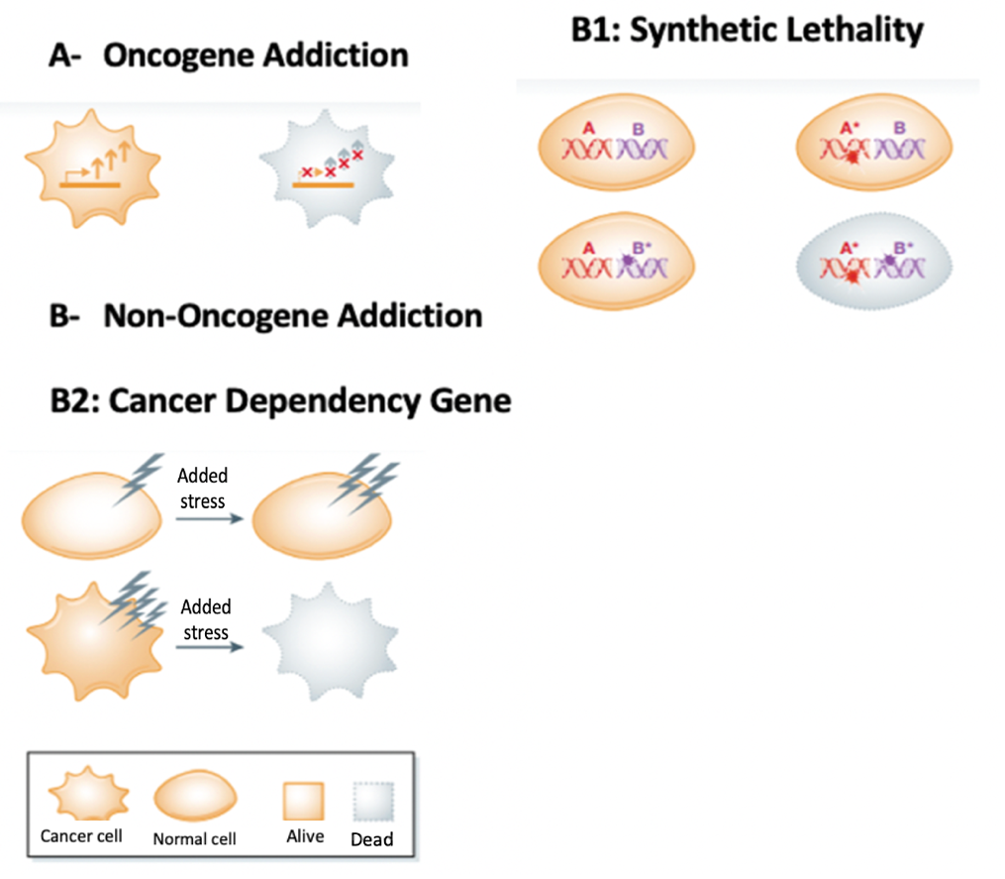
Figure 6. Schematic representation of the effect of cells undergoing oncogene addiction and non-oncogene addiction. The latter includes synthetic lethality and cancer dependency pathway or gene. (A) Oncogene addiction. When cancer cells require continuous oncogenic signalling to survive. The arrows schematically represent the increase in oncogenic signalling by the tumour cell. (B1) Synthetic lethality. When individual genes (or partaking genes involved in two SL cellular processes) undergo a mutational event, cell viability will be maintained. However, when concomitant mutation(s) occur in both genes (or genes partaking in two SL pairs of cellular processes), cell death ensues. (B2) Cancer-Dependency gene/pathway. Cancer cells continually endure variable and elevated levels of stresses, as a result of collateral events encountered during tumorigenesis. By applying additional stress or by inhibiting the specific salvage pathway, both results in killing of the cancer cell. However, such perturbations can be often tolerated by normal cells. This figure is adapted from figure 1 in Nagel et al. 2016 [43].

Introduction to Medulloblastoma
Brain tumours make up the most frequently diagnosed solid tumour in paediatric patients [44]. Medulloblastoma originates in the brain’s cerebellar region [44]. Medulloblastoma (MB) is the most common childhood malignancy of the brain, and represents 60% of paediatric brain tumours [44]. MB arises mainly in the cerebellar vermis and it is thought to originate as a result of damaged or mutated neural stem/progenitor cell during the early development [44]. Male individuals are 1.8 times more likely of developing medulloblastoma compared to female individuals [45]. The median age of diagnoses with MB is 6 years [45].
Survival rates in medulloblastoma patients have significantly improved over the last 20 years [46–48]. The overall survival of MB is 80% in patients with standard risk [49–54]. Patients with standard-risk MB are older than 3 years, also have an absence of metastatic lesion after diagnosis with MB, and have undergone gross tumour resection [54–57]. The 5-year overall survival of MB patients is less than 70%, this means that survival is still lower in high-risk patients [54–57]. The patients with high-risk MB are those whom are less than 3 years old, having undergone subtotal resection, and have been diagnosed with metastatic lesions [54–57].
By 2021, classification systems for medulloblastoma are genetically defined and includes four molecular subgroups that were defined initially by methylation and also by transcriptomic profiling by means of expression arrays, these include: WNT, SHH (Sonic Hedgehog), Group 3, and Group 4 (figure 7) [58–63]. Group 4 MB is the subgroup that is most prevalent and WNT is rare and least prevalent [62–64]. Group 3 MB has got the worst survival, while WNT has got the best survival rate [62–64].
According to Eberhart 2012 several clinical and demographic information can be stated. WNT MB usually occurs in adults and children and affect both males and females at equal rate. It rarely metastasizes and its histology is mainly classic and LCA. SHH MB occurs commonly in infants and adults and to a smaller extent in children. It equally affects males and females. SHH MB uncommonly undergoes metastasis and its histology is mainly classic, LCA and desmoplastic/nodular. Group 3 MB occurs commonly in children and less commonly in infants. It occurs more commonly in males. Group 3 MB very frequently undergoes metastasis and its histology is mainly classic and LCA. Group 4 MB occurs most commonly in children and less commonly in infants and adults. It affects males more than females. It frequently undergoes metastasis and its histology is classic and LCA. According to these data from Eberhart 2012, it suggests there is demand for specific treatment with less toxicity, especially for children and younger individuals. Therefore, targeting SL based on methylation is a very suited treatment option, owing to its specificity and less toxicity [1, 4].

Genetic changes in medulloblastoma
In addition to methylation patterns, genetic changes are also important to classify MB into the four subgroups. WNT subgroup mainly involves MYC amplification [62, 65, 66], TP53 mutation and other mutations or genetic changes especially on genes being components of the WNT signalling pathway, such as CTNNB1 [62, 67, 68]. SHH on the other hand has mutations especially on gene components of the SHH pathway, such as PTCH1, SMO, SUFU and GLI2 [62, 69]. SHH however also undergoes MYCN amplification and TP53 mutation [62, 70–73]. Group 3 involves mainly MYC amplification and has mutations on gene components of photoreceptor or GABAergic pathway [62, 74, 75]. Group 4 has minimal MYC or MYCN amplification [62, 76], but does frequently involve CDK6 amplification [62, 77, 78]. Group 4 MB mutations mainly affect those gene components of the neuronal or Glutamatergic pathway [62, 79, 80].

Already existing treatment methods for MB based on subgroup genetic changes.
As already stated, this study aims to identify specific and less toxic ways to treat Medulloblastoma and importantly other cancers too. Targeting SL based on methylation is a good approach for this. However, as stated in methods section, only MB subgroups will be considered for this project to identify candidate SL genes, because there is large number of samples for them in existing data. The sample number for subtypes of subgroups are usually smaller and therefore will not be considered.
MB subgrouping has enabled to identify effective targets for therapy that is specific for each subgroup of medulloblastoma [62]. For example, SMO epigenetic inhibitors are used specifically to treat SHH medulloblastoma and CDK4/6 epigenetic inhibitors are used to specifically treat Group 4 MB [81, 82]. Another example is EZH2 inhibitors used to specifically treat the subgroup of Group 3 and Group 4 of MB [83]. This is because EZH2 plays an important role in DNA methylation, hence why further subsetting of group 3 and group 4 MB are mainly based on methylation [83, 84]. Lastly, CDK4/6 epigenetic inhibitors are used for example to treat the MB patients with those methylation subtypes that were previously classified as Group 4 MB [62, 85, 86]. This is because Group 4 MB was known to involve CDK6 amplification [62, 85, 86].
Some other treatment methods also exist all medulloblastoma subgroups. These treatment option includes genetic inhibitors like inhibitors of PARP, EGFR, WEE-1 and ALK [62, 87–90]. Additional treatment options for all MB subgroups include epigenetic inhibitors, like HDAC inhibitors and BET/BRD inhibitors [62, 91, 92].
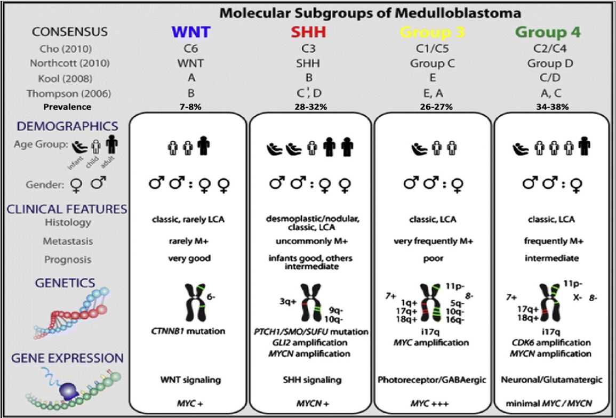
Figure 7. Comparison of the various medulloblastoma subgroups. Affiliations of these subgroups with papers that were published previously on the molecular subgrouping of medulloblastoma are also shown. LCA: Large Cell Anaplastic. This figure is adapted from figure 1 in Gerber et al. 2014 [63].
Following this initial subgrouping, further analysis has further subdivided some of the four subgroups [84, 93–96]. For example, SHH has recently been subdivided into four subsets: SHH_1, SHH_2, SHH_3 and SHH_4 [95]. Out of these subsets, SHH-1 has better survival than SHH-2. SHH_3 were further subdivided into: SHH_3A, SHH_3B and SHH_3C (figure 8) [95]. Out of these three subtypes, SHH-3A has best survival, while SHH-3C has worst survival [95]. Group 3 and group 4 were both subdivided into methylation subtypes 1 to 8 (figure 9) [84]. Out of these eight methylation subtypes: subtype VIII has got highest frequency, while subtype I is least common; and subtype V has best survival rate, while subtype III has worst survival rate [84]. However, WNT remained as WNT-alpha and WNT-beta and was not further subdivided [96].
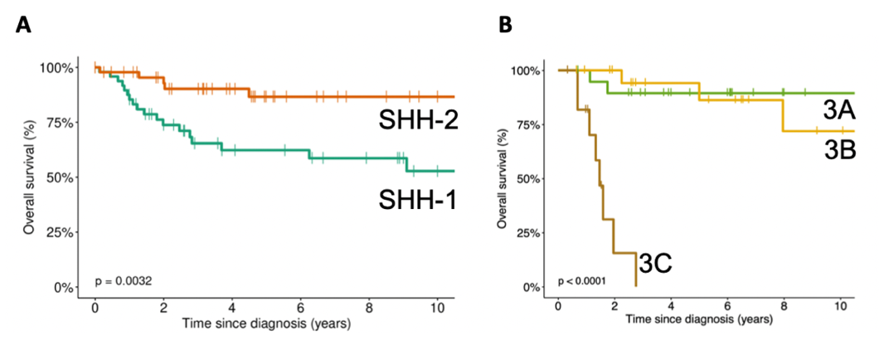
Figure 8. Overall survival among SHH subtypes of MB. (A) SHH-2 has got significantly better overall survival than SHH-1. (B) Out of the three subtypes of SHH-3, SHH-3C has got the worst overall survival. This figure is adapted from figure 6 and 7 in reference [95].
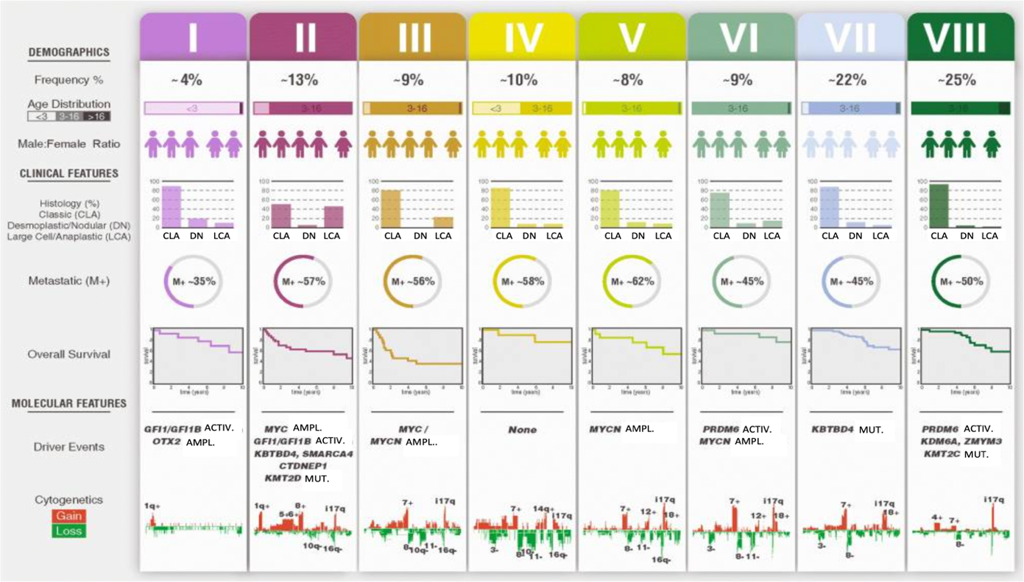
Figure 9. Summary of MB Grp3/4 molecular subtypes. Summary comprising of major demographic, clinic-pathological, and molecular features of the concordant subtypes. the source for mutational data is Northcott et al. For histology: CLA classic; DN desmoplastic nodular; LCA large-cell anaplasia. M+ (%) denotes metastatic (i.e. M1+) frequency. Overall survival shows survival in year that is subtype-specific. Cytogenic gains are shown in red and losses in green. For driver events: ACTIV activation; AMPL amplification; MUT mutation. This figure is adapted from figure 8 in Sharma et al. 2019 [84].

Methods.

Introduction to bioinformatics pipeline
The previously developed bioinformatic pipeline by Schwalbe et al., 2021 [4] that will be utilised in this analysis to get genes that might be relevant for some cancer subtypes (detailed in figure 10), such as MYCN amplified Medulloblastoma, this pipeline works by several steps:
First step is to get DMRs and using DMRCate, DMRs will be selected for a specific subtype of cancer under study. For this first step, it is important to note that we have been initially provided with the vast illumina methylation array for the 763 medulloblastoma samples. This provides us with genome-wide methylation data, which is mainly based on human 450k methylation data. Human 450k methylation data is obtained from 450 000 CpG sites (especially in promoters and present within each cell in a tumour sample from a specific cancer subtype), that will serve as sites for binding of probes specific for DNA sequences containing either methylated and unmethylated CpG sites. This analysis will result in acquiring beta-values. A beta value represents the proportion of total number of a particular CpG site that is methylated in a sample [97]. The derived beta values lie between zero (0% methylated) and one (100% methylated) [97]. In the case of my study, we have DNA methylation data or genome-wide methylation data, which have been derived from 763 medulloblastoma samples. DNA methylation data will be separated into different groups, in this case it will be based on some of the genetic aspects. The methylation data in this case can be for example separated into: MYC amplified group; MYCN amplified group; and no MYC/MYCN amplification. Therefore, initially these three groups at the beginning will be analysed. For instance, if aiming to look for SL genes that are associated for MYCN amplification, then at the beginning of the pipeline, MYCN samples will be compared to all the other samples put together, such as MYC amplified samples and samples with no MYC/MYCN amplification, both combined together. At the beginning, (for example In the case of comparing of MYCN versus all other samples), we aim to identify DMRs (Differentially Methylated Regions). DMRs should be at least two CpG sites long and will be identified mainly using DMRCate package, although other packages can be used, such as: Bumphunter, comb-p, seqlm, GlobalP and dmrff [98–100]. DMRCate uses a standard cut-off of 0.2 difference in beta value, which is equivalent to 20% difference in methylation.
Second step is to work out the maximally divergent regions (MDRs) in the DMRs identified by the above analysis. Once these DMRs have been identified to exist between those two groups, then the second step of the analysis will be to look within those DMRs to look for maximally divergent regions (MDRs). The MDR is a section within the DMR that has the biggest difference in beta value, which means the biggest difference in methylation. The only stipulation made on this, is that it should be at least two CpG sites long. The identification of an MDR starts with one CpG site that has the biggest individual difference in methylation. Then subsequent to this, the pipeline will look on either side of this CpG site to see if another CpG site. The next CpG site to be added on either side, that should give the biggest difference in methylation between our group of interest (for example the MYC amplified samples) and the other groups (consisting of MYCN amplified and no MYC/MYCN amplified samples). At this point a more stringent (than in step 1) cut-off of 0.4 is used, which is about 40% difference in beta value. This more stringent cut-off aims to look for really big differences in methylation between the group of interest and the other samples. This step will end up with a section of the DMRs comprising of two or more consecutive CpG sites, in which the average difference in beta value is at least 0.4. The consecutive CpG sites should have a lambda value of at least 1000, which means being not more than 1000 base pairs away from each other [98].
This section of DMR, i.e. MDR (Maximally Divergent Region) is carried forward to subsequent parts of step 2, which looks at gene expression data. This part of step 2 aims to associate the DMR with the closest gene. This will be done by looking at the location of the DMR within the genome and find the transcriptional start site (TSS) of a gene that is the nearest to the DMR. Usually, the DMRs occur at gene promoters and often overlap with the TSS of the gene. But the criteria stipulates that the DMR will be allowed to be up to 20kb away from the TSS of a gene. If there would be no TSS within 20kb from either ends of the DMR, then this DMR will be removed from the analysis and not considered further at that point. But if there is multiple different TSS within 20kb from either end of DMR, then the gene closest to either end of the DMR will be considered and the other gene will not be considered for further analysis. Expression data will then be analyses to see this this DMR has any association with differential expression of the gene. As a final part of step 2, the script will produce a PDF file that will include both the methylation data and the expression data. Therefore, in summary in this step, we compared cancer subtype (e.g. MYCN amplification) to all other samples containing other subtypes all together.
The third step involves comparing methylation at the Maximally Divergent Regions (MDRs) across all groups individually. In the initial part of this particular analysis, we will be for example comparing three mutually exclusive groups, which include: MYC amplified; MYCN amplified and no MYC/MYCN amplified. This step will aim to confirm if the difference in methylation (0.4 or 40%) is preserved when comparing the group of interest (for example MYCN amplified group of samples) versus all the other groups individually (MYC amplified and no MYC/MYCN amplified samples). Therefore, there must a 0.4 or 40% difference between MYCN amplified samples and MYC amplified, but also between MYCN amplified samples and no MYC/MYCN amplified samples. Both of these comparisons have to preserve 0.4 or 40% methylation difference for the DMR to proceed to further analysis. Any methylation difference close to 0.4 or 40% (e.g. 0.38 or 0.42) will be allowed for further screening if few/no candidates are identified in initial screening using the stringent 0.4 or 40% methylation cut-off.
Fourth step involves comparison of expression patterns between the group of interest and all the other groups individually. This step aims to identify a difference in expression which inversely correlates with methylation. Therefore, if there is an increase in methylation when comparing group of interest (e.g. MYCN amplified group of samples) with all other groups of samples individually (in this case MYC amplified and no MYC/MYCN amplified samples), we expect a decrease in expression. however, if there is a decrease methylation, then we should expect an increase in expression. This difference between methylation and expression should be consistent when comparing group of interest and other groups individually.

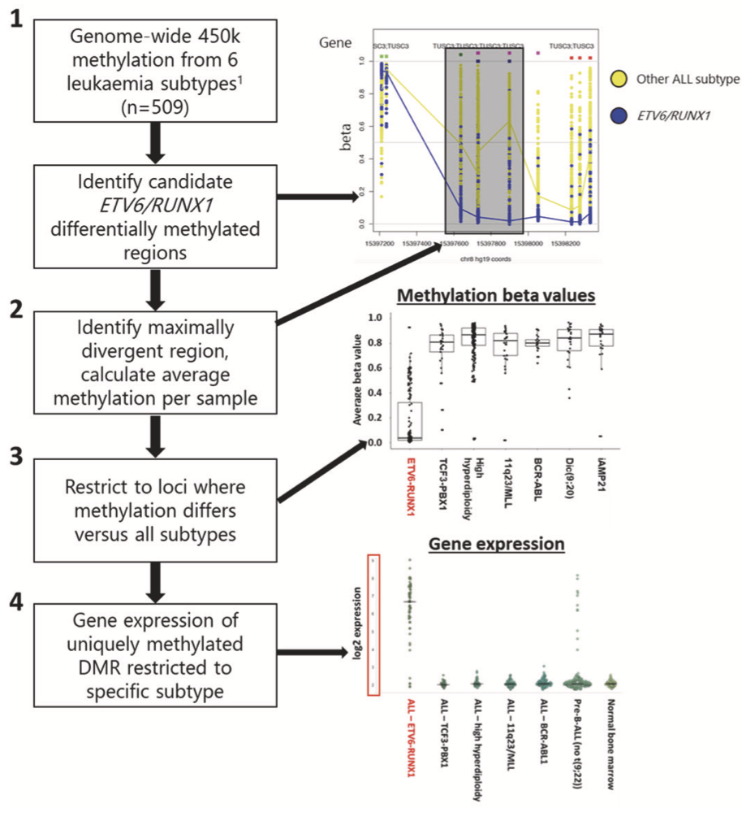
Figure 10. Flow diagram depicting the general bioinformatic pipeline that is used to identify the group of interest. The group of interest in this general diagram is shows as being ETV6/RUNX1 subgroup of Leukaemia. However, in my research as outlined before, the group of interest will be initially MYCN amplified medulloblastoma samples to be compared to two other subtypes, which are groups of MYC amplified samples and no MYC/MYCN amplified samples. 1st step involves obtaining DMRs and using DMRCate, DMRs will be selected for a specific subtype of cancer under study. 2nd step involves working out the maximally divergent regions (MDRs) in the DMRs identified by the above analysis. 3rd step involves comparing methylation at the Maximally Divergent Regions (MDRs) across all groups individually. 4th step involves comparison of expression patterns between the group of interest and all the other groups individually. Beta value means the ratio to methylation to unmethylated CpG site probes. Expression is measured in Log2, due to a presence of very large number of transcripts. This figure is adapted from figure 1 in Schwalbe et al. 2021 [4].

Project Aims
The three aims of the project are:
- To identify candidate SL/TSG genes in medulloblastoma associated with specific, disease associated, genetic changes.
In this initial aim, it is intended to identify the SL partner genes for genetic changes that are associated with medulloblastoma. Medulloblastoma was chosen as the initial cancer to assess because of local expertise, the availability of data required for the running bioinformatic pipeline and as CAS9 expressing cell line models for downstream testing of candidates are currently being developed for this tumour type.
There are a number of genetic changes associated with medulloblastoma that can be potentially compared or used for stratifications within the first aim of my project aiming to identify TSG or SL candidate genes in medulloblastoma. This analysis will serve two purposes. One of these purposes includes identifying candidate genes that should exhibit equivalent associations with for example MYCN amplification or MYC amplification, regardless of any MB subgroups or of any MB subtypes. As highlighted before, the initial examples of mutually exclusive subtypes to be compared include: 1) MYCN amplification vs 2) MYC amplification vs 3) no MYC/MYCN amplification. Another one of these two purposes includes identifying gene candidates that depend on the specific cell background, for example candidates being only relevant in a single subtype with MYCN amplification. MB Subgroups like SHH, WNT, Grp3 and Grp4 will be used for this project to identify SL genes for these subgroups with a specific initiating genetic event. but further subsets, such as SHH 1 to 4 or SHH3A to B, or lastly methylation subtypes 1 to 8 of MB will be used only if they have a large enough sample size to be considered for analysis. When stratifying by molecular subtype of medulloblastoma. As an example in the case of MYCN amplification, the following genetic abnormalities together with MB molecular subtype would be considered for analysis: 1) WNT no MYCN amplification vs 2) SHH + MYCN amplification vs 3) SHH no MYCN amplification vs 4) Grp3 no MYCN amplification vs 5) Grp4 + MYCN amplification vs 6) Grp4 no MYCN amplification. It should be especially noted that group 3 MB with MYCN amplification could be included as a group to make the comparison against. This means for example they could be used to assess with MYCN amplification in other subtypes are similar group 3 MB with MYCN. However, they could not be used for specific analysis or as a subject of analysis for candidate genes against all other subtypes. This is because there are very few samples with Group 3 MB and MYCN amplification.
Other genetic changes within medulloblastoma would also be analysed and looked at, for example TP53 mutation with a specific MB subtype. However, initially focus will be on analysing MYC and MYCN amplifications.
As mentioned, if sample numbers are large enough in available data, then methylation subgroups 1 to 8 (Group 3 and Group 4 MB) with metastasis can also possibly be compared to those without metastasis [101]. This will also enable us to find more TSG or SL candidate genes in medulloblastoma [101]. This is because a myriad of genes cause metastasis [101], and can potentially form SL pairs with other genes to undergo methylation and expression analysis.
This first aim intends to establish proof-of-principal that SL gene candidates, specific for individual genetic aberrations, can be identified by this approach. In addition, it will identify candidate gene that can be assessed in other types of cancer to determine if the candidate SL genes are associated with their genetic partner independent of the specific cancer type in which the mutation occurs.
Conumee analysis has already been performed in aim 1 to identify CNV aberrations for analysis. Conumee is a software tool used in order to infer CNVs from methylation arrays, i.e. from human 450k methylation beadchip array [102, 103]. So far, important mutually exclusive genetic driver events are properly defined, which include MYC amplification and MYCN amplification and analysis to identify candidate genes associated with these genetic abnormalities will be carried out shortly.

- Determine if SL gene candidates identified as related to specific genetic defects in one cancer type play similar roles in other cancer types in which the same genetic defect has been identified.
This aim will assess whether synthetic lethal targets specific for genetic defects in medulloblastoma may also be relevant in other cancers which exhibit the same genetic defect. Data will be obtained from publicly available sources, particularly the TCGA and GEO. Consequently, this analysis will have three broad categories of outcomes. 1) Direct replication, in which highly similar differences in methylation/expression are seen to be associated with the candidate across some or all other cancer types analysed. 2) partial replication, in which differences in methylation/expression are observed, but these are less pronounced in other cancer types, suggesting a more limited requirement for the candidate gene in the presence of its corresponding cancer associated genetic change. 3) No replication, in which the candidate gene does not demonstrate evidence of similar differences in methylation/expression. Out of these outcomes, there will be priority for SL gene candidates having the first outcome in order to undergo subsequent functional confirmation in aim 3, described further below. The SL genes that exhibited partial replication will be considered to undergo functional analysis and will be restricted to the type of cancer in which the extent of differential methylation/expression matches or surpasses the cut-offs used to define candidates in our bioinformatic pipeline.

- Functional analysis of the identified candidates identified in the first two aims in cell line models utilising a CRISPR based approach.
Using CRISPR-based screening approach (recently published by Girish and Sheltzer in 2020) [104], functional assays will be performed by utilizing suitable cell line models to assess the identified SL candidates for cell growth or survival. The advantage of CRISPR-Cas9 system is that CRISPR-Cas9 system can enable the assessment of the impact of completely inactivating a gene [105, 106], unlike other methods like shRNA or siRNA, which typically result in partial knockdown [105, 106].
The approach to be used is illustrated on figure 11. A number of factors will be considered to prioritise candidates for the analysis: a) identified as being an SL gene candidate to be associated with a specific mutation in multiple cancer types, b) identified as an SL candidate having a panel of suitable cell lines expressing CAS9 in a specific cancer type, c) identified as an SL candidate associated with a mutation and being related to a poor outcome in or several types of tumour, d) SL gene candidates which are already known to have one or multiple small molecule inhibitors. This particular candidate will be prioritised if the known small molecule inhibitor is in clinical trials or currently used in clinic, enabling rapid translation for the target.

The procedure using CRISPR-Cas9 system is carried out according to procedures stipulated by Girish et al. 2020 [107]. As shows in Figure 11A, initially in this CRISPR-Cas9 procedure, MB cell line models will be provided that have been initially stably transduced with a Cas9 expression vector, which has a selectable marker on it. The availability of type of cell line to be provided depends on cell line availability, for example there are MB cell lines available having MYC amplification, but MB cell lines with MYCN amplification are not currently available. This selectable marker is a Puromycin selectable marker. This selectable marker will enable the cells to survive when puromycin is added. The addition of puromycin will ensure that only those cells with Cas9 expression vector will survive, i.e. having 100% of all cells being Cas9 positive. The subsequent parts of wet lab approach will aim to test if the identified SL gene candidates are actually synthetic lethal. As an example, candidate SL genes to be tested can be Synthetic lethal with MYC amplification. However, another set of cell lines should not have MYC amplification, in order to differentiate between Synthetic lethality in cell lines with MYC amplification and cell lines without MYC amplification. Then subsequently the Cas9 positive cells will be used to set up three different plates. Each of these three plates will be transduced with a different lentiviral vector, that contains a different type of sgRNA vector as well as a fluorescent protein. mCherry will be the fluorescent protein to be used in my project, although the figure shows GFP fluorescent protein being used. The three plates will include: a positive control; a negative control; and a plate with sgRNA for gene of interest. In the positive control (top plate), the sgRNA is directed against a gene that is essential for growth of all types of cells (RPA3 [108, 109]), therefore inactivating this gene will cause cell death. In the negative control (bottom plate), the sgRNA will be directed against a gene that is not essential for cell growth (ROSA26 [110, 111]), therefore inactivating the gene will not cause cell death. The middle plate contains a vector with sgRNA directed against the gene of interest. As shown in part (B) of figure 11, Cells will be infected with Cas9 on the first day. Then after about 15 days, it is expected that the positive control should have reduced fluorescence from 50% to a very small percentage, close to zero percent. However, it is also expected that the negative control, should maintain the 50% fluorescence. At the end of the experiment, if the results from the plate with the gene of interest shows similar amount of fluorescence as the positive control, then the gene of interest is synthetically lethal with the specific genetic initiating event. Conversely, if the results from the plate with gene of interest shows similar amount of fluorescence as the negative control, then the gene of interest would not be synthetically lethal. Sometimes the sgRNA can be ineffective and not functional. In this case, the test can be repeated second time or up to third time with a second and third sgRNA of the same type. However, some cells can undergo DNA sequencing to test if the sgRNA has undertaken its role and to confirm if the second or third sgRNA is still not working. Sometimes sgRNA can target a different gene that is also required for cell growth and causes reduced fluorescence. To test if this is the case, the test can be repeated with a different sgRNA.
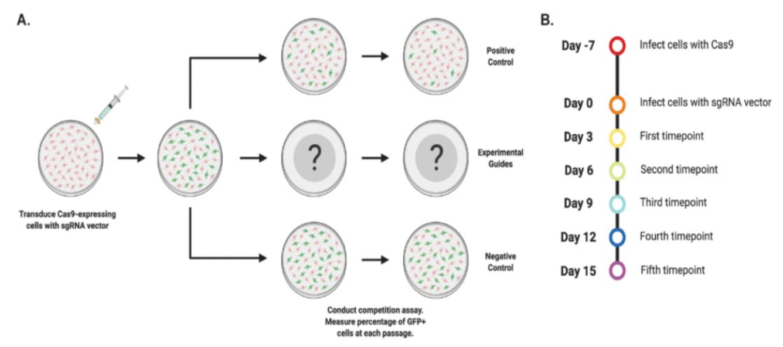
Figure 11. CRISPR-based approach used for functional analysis of the identified SL candidates. (A) initially in this CRISPR-Cas9 procedure, MB cell line models will be provided that have been initially stably transduced with a Cas9 expression vector, which has a selectable marker on it. This selectable marker is a Puromycin selectable marker, which enables to only select the cells that survive when puromycin is added. Then subsequently the Cas9 positive cells will be used to set up three different plates. Each of these plates contain a lentiviral vector with a fluorescent protein (e.g. GFP) and a different type of sgRNA. One plate includes the positive control (top plate), in which the sgRNA is directed against a gene that is essential for growth of all types of cells. Another plate includes negative control (bottom plate), the sgRNA will be directed against a gene that is not essential for cell growth. The middle plate contains a vector with sgRNA directed against the gene of interest. (B) Cells will be infected with Cas9 on the first day. Then after about 15 days, it is expected that the positive control should have reduced fluorescence from 50% to a very small percentage, close to zero percent. However, it is also expected that the negative control, should maintain the 50% fluorescence. At the end of the experiment, if the results from the plate with the gene of interest shows similar amount of fluorescence as the positive control, then the gene of interest is synthetically lethal with the specific genetic initiating event. However, if not showing similar amount of fluorescence as positive control, then the gene of interest is not synthetic lethal with specific initiating genetic event. This figure is adapted from figure 1 in Girish et al. 2020 [107].

Mitigations.
Although previous analyses do suggest that identified SL candidates in aim 1 is potentially relevant in other cancers (aim 2). However, should they not be relevant in aim 2, then they could still proceed into wet lab analysis in aim 3 directly from aim 1 without undertaking aim 2 analyses on these candidates. In the unlikely event of having no candidates identified at all in aim 1, then candidates identified in non-medulloblastoma samples in aim 2, can progress into aim 3 functional assessment.

Limitations of my project.
There are several limitations to the analyses to be carried out in my project. The first limitation is that the approach taken in this project can only identify Synthetic lethal gene if in the gene is not synthetic lethal, then it gets methylated. Therefore, resulting in methylation difference between cells with one subtype and cells with all other subtypes. However, If the gene never becomes methylated in all cells, then there will never be a methylation difference and will not be possible to be assessed. Another limitation is that it not possible to find the optimal average beta value cut-off for the bioinformatic pipeline. We cannot define a cut-off that will give only positive SL candidates (optimal specificity) and no negative candidates at all (minimal sensitivity). Higher cut-off will give higher specificity and lower cut-off will give higher sensitivity.

Future work Gantt Chart.
Future work commitments | 2nd year – 2025 to 2026
 | Mar | Apr |  | May |  | Jun |  | Jul |  |  | Aug |  |  | Sept |  |  | Oct | Nov |  |  | Dec | Jan | Feb
identify potential SL or TSG candidates associated with particular genetic defects using conumee and other mutational data
Obtain TCGA, GEO and other mutational data for other cancers,
Assess the SL and TSG candidates from analysis done on genetic defects in medulloblastoma and confirm SL or TSG roles in other cancers (2nd part of aim 2)
Completion of aim 1 and aim 2.
Future work commitments | 3rd year – 2026 to 2027
 | Mar | Apr |  | May |  | Jun |  | Jul |  |  | Aug |  |  | Sept |  |  | Oct |  | Nov |  | Dec | Jan | Feb
Start lab-based analysis and start preparing CAS9 cell lines.
in Aim 3, test SL or TSG candidates, which were obtained in aim 1 and also were confirmed in other cancers in aim 2, in Cas9 cell line models of Medulloblastoma, using CRISPR.
Future work commitments | 4th year – 2027
 | Mar |  | Apr |  | May |  | Jun |  | Jul |  |  | Aug |  |  | Sept |  | Oct |  | Nov |  | Dec | Jan | Feb
Thesis corrections and viva |  |  |  |  |  |  |  |  |  |  |  |  |  |  | End of PhD degree
Table 5. Gant Chart showing Upcoming research commitments for this year and the years that will follow.

References.

1. O’Neil, N.J., Bailey, M.L., Hieter, P.: Synthetic lethality and cancer. Nat Rev Genet. 18, 613–623 (2017). https://doi.org/10.1038/nrg.2017.47
2. Dobzhansky, T.: GENETICS OF NATURAL POPULATIONS. XIII. RECOMBINATION AND VARIABILITY IN POPULATIONS OF DROSOPHILA PSEUDOOBSCURA. Genetics. 31, 269–290 (1946). https://doi.org/10.1093/genetics/31.3.269
3. Bridges, C.B.: The Mutant Crossveinless in Drosophila Melanogaster. Proceedings of the National Academy of Sciences. 6, 660–663 (1920). https://doi.org/10.1073/pnas.6.11.660
4. Schwalbe, E.C., H, L., Lafta, F., Barrow, T.M., Strathdee, G.: Integration of genome-level data to allow identification of subtype-specific vulnerability genes as novel therapeutic targets. Oncogene. 40, 5213–5223 (2021). https://doi.org/10.1038/s41388-021-01923-1
5. Stratton, M.R.: Exploring the Genomes of Cancer Cells: Progress and Promise. Science (1979). 331, 1553–1558 (2011). https://doi.org/10.1126/science.1204040
6. Hsieh, A.L., Dang, C. V.: MYC, Metabolic Synthetic Lethality, and Cancer. Presented at the (2016)
7. Kaelin, W.G.: The Concept of Synthetic Lethality in the Context of Anticancer Therapy. Nat Rev Cancer. 5, 689–698 (2005). https://doi.org/10.1038/nrc1691
8. Kwok, M., Agathanggelou, A., Davies, N., Stankovic, T.: Targeting the p53 Pathway in CLL: State of the Art and Future Perspectives. Cancers (Basel). 13, 4681 (2021). https://doi.org/10.3390/cancers13184681
9. Megchelenbrink, W., Katzir, R., Lu, X., Ruppin, E., Notebaart, R.A.: Synthetic dosage lethality in the human metabolic network is highly predictive of tumor growth and cancer patient survival. Proceedings of the National Academy of Sciences. 112, 12217–12222 (2015). https://doi.org/10.1073/pnas.1508573112
10. Chan, D.A., Giaccia, A.J.: Harnessing synthetic lethal interactions in anticancer drug discovery. Nat Rev Drug Discov. 10, 351–364 (2011). https://doi.org/10.1038/nrd3374
11. Chabanon, R.M., Postel-Vinay, S.: A Novel Synthetic Lethal Approach to Target MYC-Driven Cancers. Cancer Res. 82, 969–971 (2022). https://doi.org/10.1158/0008-5472.CAN-22-0302
12. Measday, V., Hieter, P.: Synthetic dosage lethality. Presented at the (2002)
13. Pujade-Lauraine, E., Ledermann, J.A., Penson, R.T., Oza, A.M., Korach, J., Huzarski, T., Poveda, A., Pignata, S., Friedlander, M., Colombo, N.: Treatment with olaparib monotherapy in the maintenance setting significantly improves progression-free survival in patients with platinum-sensitive relapsed ovarian cancer: Results from the phase III SOLO2 study. Gynecol Oncol. 145, 219–220 (2017). https://doi.org/10.1016/j.ygyno.2017.03.505
14. Hartwell, L.H., Szankasi, P., Roberts, C.J., Murray, A.W., Friend, S.H.: Integrating Genetic Approaches into the Discovery of Anticancer Drugs. Science (1979). 278, 1064–1068 (1997). https://doi.org/10.1126/science.278.5340.1064
15. Helleday, T.: The underlying mechanism for the PARP and BRCA synthetic lethality: clearing up the misunderstandings. Mol Oncol. 5, 387–93 (2011). https://doi.org/10.1016/j.molonc.2011.07.001
16. Bestor, T.H.: The DNA methyltransferases of mammals. Hum Mol Genet. 9, 2395–2402 (2000). https://doi.org/10.1093/hmg/9.16.2395
17. Baylin, S.B.: DNA methylation and gene silencing in cancer. Nat Clin Pract Oncol. 2, S4–S11 (2005). https://doi.org/10.1038/ncponc0354
18. Esteller, M.: ABERRANT DNA METHYLATION AS A CANCER-INDUCING MECHANISM. Annu Rev Pharmacol Toxicol. 45, 629–656 (2005). https://doi.org/10.1146/annurev.pharmtox.45.120403.095832
19. Bird, A.: DNA methylation patterns and epigenetic memory. Genes Dev. 16, 6–21 (2002). https://doi.org/10.1101/gad.947102
20. Clouaire, T., Stancheva, I.: Methyl-CpG binding proteins: specialized transcriptional repressors or structural components of chromatin? Cell Mol Life Sci. 65, 1509–22 (2008). https://doi.org/10.1007/s00018-008-7324-y
21. Strathdee, G., Brown, R.: Aberrant DNA methylation in cancer: potential clinical interventions. Expert Rev Mol Med. 4, 1–17 (2002). https://doi.org/10.1017/S1462399402004222
22. Gowher, H., Liebert, K., Hermann, A., Xu, G., Jeltsch, A.: Mechanism of stimulation of catalytic activity of Dnmt3A and Dnmt3B DNA-(cytosine-C5)-methyltransferases by Dnmt3L. J Biol Chem. 280, 13341–8 (2005). https://doi.org/10.1074/jbc.M413412200
23. Robert, M.-F., Morin, S., Beaulieu, N., Gauthier, F., Chute, I.C., Barsalou, A., MacLeod, A.R.: DNMT1 is required to maintain CpG methylation and aberrant gene silencing in human cancer cells. Nat Genet. 33, 61–65 (2003). https://doi.org/10.1038/ng1068
24. Okano, M., Bell, D.W., Haber, D.A., Li, E.: DNA methyltransferases Dnmt3a and Dnmt3b are essential for de novo methylation and mammalian development. Cell. 99, 247–57 (1999). https://doi.org/10.1016/s0092-8674(00)81656-6
25. Bashtrykov, P., Jankevicius, G., Smarandache, A., Jurkowska, R.Z., Ragozin, S., Jeltsch, A.: Specificity of Dnmt1 for methylation of hemimethylated CpG sites resides in its catalytic domain. Chem Biol. 19, 572–8 (2012). https://doi.org/10.1016/j.chembiol.2012.03.010
26. Sallam, M., Benotmane, M.A., Baatout, S., Guns, P.-J., Aerts, A.: Radiation-induced cardiovascular disease: an overlooked role for DNA methylation? Epigenetics. 17, 59–80 (2022). https://doi.org/10.1080/15592294.2021.1873628
27. Bird, A.P.: CpG-rich islands and the function of DNA methylation. Nature. 321, 209–213 (1986). https://doi.org/10.1038/321209a0
28. Luo, Y., Lu, X., Xie, H.: Dynamic Alu methylation during normal development, aging, and tumorigenesis. Biomed Res Int. 2014, 784706 (2014). https://doi.org/10.1155/2014/784706
29. Babenko, V.N., Chadaeva, I. V, Orlov, Y.L.: Genomic landscape of CpG rich elements in human. BMC Evol Biol. 17, 19 (2017). https://doi.org/10.1186/s12862-016-0864-0
30. Strichman-Almashanu, L.Z., Lee, R.S., Onyango, P.O., Perlman, E., Flam, F., Frieman, M.B., Feinberg, A.P.: A genome-wide screen for normally methylated human CpG islands that can identify novel imprinted genes. Genome Res. 12, 543–54 (2002). https://doi.org/10.1101/gr.224102
31. Takai, D., Jones, P.A.: Comprehensive analysis of CpG islands in human chromosomes 21 and 22. Proc Natl Acad Sci U S A. 99, 3740–5 (2002). https://doi.org/10.1073/pnas.052410099
32. Jueliger, S., Taverna, P., Re, O. Lo, Vinciguerra, M.: Senescence Induced by DNA Demethylating Drugs to Treat Solid Tumors. In: Handbook of Immunosenescence. pp. 1–30. Springer International Publishing, Cham (2018)
33. McCabe, M.T., Brandes, J.C., Vertino, P.M.: Cancer DNA methylation: molecular mechanisms and clinical implications. Clin Cancer Res. 15, 3927–37 (2009). https://doi.org/10.1158/1078-0432.CCR-08-2784
34. Feinberg, A.P., Irizarry, R.A.: Stochastic epigenetic variation as a driving force of development, evolutionary adaptation, and disease. Proceedings of the National Academy of Sciences. 107, 1757–1764 (2010). https://doi.org/10.1073/pnas.0906183107
35. Jones, P.A.: DNA methylation and cancer. Cancer Res. 46, 461–6 (1986)
36. Delpu, Y., Cordelier, P., Cho, W.C., Torrisani, J.: DNA methylation and cancer diagnosis. Int J Mol Sci. 14, 15029–58 (2013). https://doi.org/10.3390/ijms140715029
37. Baylin, S.B.: DNA methylation and gene silencing in cancer. Nat Clin Pract Oncol. 2, S4–S11 (2005). https://doi.org/10.1038/ncponc0354
38. Varela-Rey, M., Woodhoo, A., Martinez-Chantar, M.-L., Mato, J.M., Lu, S.C.: Alcohol, DNA methylation, and cancer. Alcohol Res. 35, 25–35 (2013)
39. Ciolfi, A., Aref-Eshghi, E., Pizzi, S., Pedace, L., Miele, E., Kerkhof, J., Flex, E., Martinelli, S., Radio, F.C., Ruivenkamp, C.A.L., Santen, G.W.E., Bijlsma, E., Barge-Schaapveld, D., Ounap, K., Siu, V.M., Kooy, R.F., Dallapiccola, B., Sadikovic, B., Tartaglia, M.: Frameshift mutations at the C-terminus of HIST1H1E result in a specific DNA hypomethylation signature. Clin Epigenetics. 12, 7 (2020). https://doi.org/10.1186/s13148-019-0804-0
40. Tawfeeq, M.T., Voordeckers, K., van den Berg, P., Govers, S.K., Michiels, J., Verstrepen, K.J.: Mutational robustness and the role of buffer genes in evolvability. EMBO J. 43, 2294–2307 (2024). https://doi.org/10.1038/s44318-024-00109-1
41. Muñoz, P., Iliou, M.S., Esteller, M.: Epigenetic alterations involved in cancer stem cell reprogramming. Mol Oncol. 6, 620–636 (2012). https://doi.org/10.1016/j.molonc.2012.10.006
42. Luo, J., Solimini, N.L., Elledge, S.J.: Principles of Cancer Therapy: Oncogene and Non-oncogene Addiction. Cell. 136, 823–837 (2009). https://doi.org/10.1016/j.cell.2009.02.024
43. Nagel, R., Semenova, E.A., Berns, A.: Drugging the addict: non‐oncogene addiction as a target for cancer therapy. EMBO Rep. 17, 1516–1531 (2016). https://doi.org/10.15252/embr.201643030
44. DeSouza, R.-M., Jones, B.R.T., Lowis, S.P., Kurian, K.M.: Pediatric medulloblastoma - update on molecular classification driving targeted therapies. Front Oncol. 4, 176 (2014). https://doi.org/10.3389/fonc.2014.00176
45. Suk, Y., Gwynne, W.D., Burns, I., Venugopal, C., Singh, S.K.: Childhood Medulloblastoma: An Overview. Methods Mol Biol. 2423, 1–12 (2022). https://doi.org/10.1007/978-1-0716-1952-0_1
46. Jakacki, R.I., Burger, P.C., Zhou, T., Holmes, E.J., Kocak, M., Onar, A., Goldwein, J., Mehta, M., Packer, R.J., Tarbell, N., Fitz, C., Vezina, G., Hilden, J., Pollack, I.F.: Outcome of Children With Metastatic Medulloblastoma Treated With Carboplatin During Craniospinal Radiotherapy: A Children’s Oncology Group Phase I/II Study. Journal of Clinical Oncology. 30, 2648–2653 (2012). https://doi.org/10.1200/JCO.2011.40.2792
47. Oyharcabal-Bourden, V., Kalifa, C., Gentet, J.C., Frappaz, D., Edan, C., Chastagner, P., Sariban, E., Pagnier, A., Babin, A., Pichon, F., Neuenschwander, S., Vinchon, M., Bours, D., Mosseri, V., Le Gales, C., Ruchoux, M., Carrie, C., Doz, F.: Standard-risk medulloblastoma treated by adjuvant chemotherapy followed by reduced-dose craniospinal radiation therapy: a French Society of Pediatric Oncology Study. J Clin Oncol. 23, 4726–34 (2005). https://doi.org/10.1200/JCO.2005.00.760
48. Gajjar, A., Chintagumpala, M., Ashley, D., Kellie, S., Kun, L.E., Merchant, T.E., Woo, S., Wheeler, G., Ahern, V., Krasin, M.J., Fouladi, M., Broniscer, A., Krance, R., Hale, G.A., Stewart, C.F., Dauser, R., Sanford, R.A., Fuller, C., Lau, C., Boyett, J.M., Wallace, D., Gilbertson, R.J.: Risk-adapted craniospinal radiotherapy followed by high-dose chemotherapy and stem-cell rescue in children with newly diagnosed medulloblastoma (St Jude Medulloblastoma-96): long-term results from a prospective, multicentre trial. Lancet Oncol. 7, 813–820 (2006). https://doi.org/10.1016/S1470-2045(06)70867-1
49. Michalski, J.M., Janss, A.J., Vezina, L.G., Smith, K.S., Billups, C.A., Burger, P.C., Embry, L.M., Cullen, P.L., Hardy, K.K., Pomeroy, S.L., Bass, J.K., Perkins, S.M., Merchant, T.E., Colte, P.D., Fitzgerald, T.J., Booth, T.N., Cherlow, J.M., Muraszko, K.M., Hadley, J., Kumar, R., Han, Y., Tarbell, N.J., Fouladi, M., Pollack, I.F., Packer, R.J., Li, Y., Gajjar, A., Northcott, P.A.: Children’s Oncology Group Phase III Trial of Reduced-Dose and Reduced-Volume Radiotherapy With Chemotherapy for Newly Diagnosed Average-Risk Medulloblastoma. Journal of Clinical Oncology. 39, 2685–2697 (2021). https://doi.org/10.1200/JCO.20.02730
50. Gajjar, A., Chintagumpala, M., Ashley, D., Kellie, S., Kun, L.E., Merchant, T.E., Woo, S., Wheeler, G., Ahern, V., Krasin, M.J., Fouladi, M., Broniscer, A., Krance, R., Hale, G.A., Stewart, C.F., Dauser, R., Sanford, R.A., Fuller, C., Lau, C., Boyett, J.M., Wallace, D., Gilbertson, R.J.: Risk-adapted craniospinal radiotherapy followed by high-dose chemotherapy and stem-cell rescue in children with newly diagnosed medulloblastoma (St Jude Medulloblastoma-96): long-term results from a prospective, multicentre trial. Lancet Oncol. 7, 813–820 (2006). https://doi.org/10.1016/S1470-2045(06)70867-1
51. Gajjar, A., Robinson, G.W., Smith, K.S., Lin, T., Merchant, T.E., Chintagumpala, M., Mahajan, A., Su, J., Bouffet, E., Bartels, U., Schechter, T., Hassall, T., Robertson, T., Nicholls, W., Gururangan, S., Schroeder, K., Sullivan, M., Wheeler, G., Hansford, J.R., Kellie, S.J., McCowage, G., Cohn, R., Fisher, M.J., Krasin, M.J., Stewart, C.F., Broniscer, A., Buchhalter, I., Tatevossian, R.G., Orr, B.A., Neale, G., Klimo, P., Boop, F., Srinivasan, A., Pfister, S.M., Gilbertson, R.J., Onar-Thomas, A., Ellison, D.W., Northcott, P.A.: Outcomes by Clinical and Molecular Features in Children With Medulloblastoma Treated With Risk-Adapted Therapy: Results of an International Phase III Trial (SJMB03). Journal of Clinical Oncology. 39, 822–835 (2021). https://doi.org/10.1200/JCO.20.01372
52. Packer, R.J., Gajjar, A., Vezina, G., Rorke-Adams, L., Burger, P.C., Robertson, P.L., Bayer, L., LaFond, D., Donahue, B.R., Marymont, M.H., Muraszko, K., Langston, J., Sposto, R.: Phase III Study of Craniospinal Radiation Therapy Followed by Adjuvant Chemotherapy for Newly Diagnosed Average-Risk Medulloblastoma. Journal of Clinical Oncology. 24, 4202–4208 (2006). https://doi.org/10.1200/JCO.2006.06.4980
53. Lazow, M.A., Palmer, J.D., Fouladi, M., Salloum, R.: Medulloblastoma in the Modern Era: Review of Contemporary Trials, Molecular Advances, and Updates in Management. Neurotherapeutics. 19, 1733–1751 (2022). https://doi.org/10.1007/s13311-022-01273-0
54. Huybrechts, S., Le Teuff, G., Tauziède-Espariat, A., Rossoni, C., Chivet, A., Indersie, É., Varlet, P., Puget, S., Abbas, R., Ayrault, O., Guerrini-Rousseau, L., Grill, J., Valteau-Couanet, D., Dufour, C.: Prognostic Clinical and Biologic Features for Overall Survival after Relapse in Childhood Medulloblastoma. Cancers (Basel). 13, (2020). https://doi.org/10.3390/cancers13010053
55. Martin, A.M., Raabe, E., Eberhart, C., Cohen, K.J.: Management of pediatric and adult patients with medulloblastoma. Curr Treat Options Oncol. 15, 581–94 (2014). https://doi.org/10.1007/s11864-014-0306-4
56. Packer, R.J., Gajjar, A., Vezina, G., Rorke-Adams, L., Burger, P.C., Robertson, P.L., Bayer, L., LaFond, D., Donahue, B.R., Marymont, M.H., Muraszko, K., Langston, J., Sposto, R.: Phase III Study of Craniospinal Radiation Therapy Followed by Adjuvant Chemotherapy for Newly Diagnosed Average-Risk Medulloblastoma. Journal of Clinical Oncology. 24, 4202–4208 (2006). https://doi.org/10.1200/JCO.2006.06.4980
57. Zeltzer, P.M., Boyett, J.M., Finlay, J.L., Albright, A.L., Rorke, L.B., Milstein, J.M., Allen, J.C., Stevens, K.R., Stanley, P., Li, H., Wisoff, J.H., Geyer, J.R., McGuire-Cullen, P., Stehbens, J.A., Shurin, S.B., Packer, R.J.: Metastasis Stage, Adjuvant Treatment, and Residual Tumor Are Prognostic Factors for Medulloblastoma in Children: Conclusions From the Children’s Cancer Group 921 Randomized Phase III Study. Journal of Clinical Oncology. 17, 832–832 (1999). https://doi.org/10.1200/JCO.1999.17.3.832
58. Cho, Y.-J., Tsherniak, A., Tamayo, P., Santagata, S., Ligon, A., Greulich, H., Berhoukim, R., Amani, V., Goumnerova, L., Eberhart, C.G., Lau, C.C., Olson, J.M., Gilbertson, R.J., Gajjar, A., Delattre, O., Kool, M., Ligon, K., Meyerson, M., Mesirov, J.P., Pomeroy, S.L.: Integrative genomic analysis of medulloblastoma identifies a molecular subgroup that drives poor clinical outcome. J Clin Oncol. 29, 1424–30 (2011). https://doi.org/10.1200/JCO.2010.28.5148
59. Northcott, P.A., Korshunov, A., Witt, H., Hielscher, T., Eberhart, C.G., Mack, S., Bouffet, E., Clifford, S.C., Hawkins, C.E., French, P., Rutka, J.T., Pfister, S., Taylor, M.D.: Medulloblastoma Comprises Four Distinct Molecular Variants. Journal of Clinical Oncology. 29, 1408–1414 (2011). https://doi.org/10.1200/JCO.2009.27.4324
60. Thompson, M.C., Fuller, C., Hogg, T.L., Dalton, J., Finkelstein, D., Lau, C.C., Chintagumpala, M., Adesina, A., Ashley, D.M., Kellie, S.J., Taylor, M.D., Curran, T., Gajjar, A., Gilbertson, R.J.: Genomics Identifies Medulloblastoma Subgroups That Are Enriched for Specific Genetic Alterations. Journal of Clinical Oncology. 24, 1924–1931 (2006). https://doi.org/10.1200/JCO.2005.04.4974
61. Kool, M., Koster, J., Bunt, J., Hasselt, N.E., Lakeman, A., van Sluis, P., Troost, D., Meeteren, N.S., Caron, H.N., Cloos, J., Mršić, A., Ylstra, B., Grajkowska, W., Hartmann, W., Pietsch, T., Ellison, D., Clifford, S.C., Versteeg, R.: Integrated Genomics Identifies Five Medulloblastoma Subtypes with Distinct Genetic Profiles, Pathway Signatures and Clinicopathological Features. PLoS One. 3, e3088 (2008). https://doi.org/10.1371/journal.pone.0003088
62. Haltom, A.R., Toll, S.A., Cheng, D., Maegawa, S., Gopalakrishnan, V., Khatua, S.: Medulloblastoma epigenetics and the path to clinical innovation. J Neurooncol. 150, 35–46 (2020). https://doi.org/10.1007/s11060-020-03591-9
63. Gerber, N.U., Mynarek, M., von Hoff, K., Friedrich, C., Resch, A., Rutkowski, S.: Recent developments and current concepts in medulloblastoma. Cancer Treat Rev. 40, 356–365 (2014). https://doi.org/10.1016/j.ctrv.2013.11.010
64. Eberhart, C.G.: Three Down and One To Go: Modeling Medulloblastoma Subgroups. Cancer Cell. 21, 137–138 (2012). https://doi.org/10.1016/j.ccr.2012.01.013
65. Hartley, R., Phoenix, T.N.: MYC Promotes Aggressive Growth and Metastasis of a WNT-Medulloblastoma Mouse Model. Dev Neurosci. 46, 167–178 (2024). https://doi.org/10.1159/000533270
66. Helgager, J., Pytel, P., Vasudevaraja, V., Lee, E.Q., Snuderl, M., Iorgulescu, J.B., Ligon, K.L.: WNT-Activated Medulloblastomas With Hybrid Molecular Subtypes. JCO Precis Oncol. 348–354 (2020). https://doi.org/10.1200/PO.19.00332
67. Moreno, D.A., Bonatelli, M., Antoniazzi, A.P., de Paula, F.E., Leal, L.F., Garcia, F.A. de O., de Paula, A.E., Teixeira, G.R., Santana, I.V.V., Saggioro, F., Neder, L., Valera, E.T., Scrideli, C.A., Stavale, J., Malheiros, S.M.F., Lima, M., Hajj, G.N.M., Garcia-Rivello, H., Christiansen, S., Nunes, S., Gil-da-Costa, M.J., Pinheiro, J., Martins, F.D., Junior, C.A., Mançano, B.M., Reis, R.M.: High frequency of WNT-activated medulloblastomas with CTNNB1 wild type suggests a higher proportion of hereditary cases in a Latin-Iberian population. Front Oncol. 13, 1237170 (2023). https://doi.org/10.3389/fonc.2023.1237170
68. Zhukova, N., Ramaswamy, V., Remke, M., Martin, D.C., Castelo-Branco, P., Zhang, C.H., Fraser, M., Tse, K., Poon, R., Shih, D.J.H., Baskin, B., Ray, P.N., Bouffet, E., Dirks, P., von Bueren, A.O., Pfaff, E., Korshunov, A., Jones, D.T.W., Northcott, P.A., Kool, M., Pugh, T.J., Pomeroy, S.L., Cho, Y.-J., Pietsch, T., Gessi, M., Rutkowski, S., Bognár, L., Cho, B.-K., Eberhart, C.G., Conter, C.F., Fouladi, M., French, P.J., Grajkowska, W.A., Gupta, N., Hauser, P., Jabado, N., Vasiljevic, A., Jung, S., Kim, S.-K., Klekner, A., Kumabe, T., Lach, B., Leonard, J.R., Liau, L.M., Massimi, L., Pollack, I.F., Ra, Y.S., Rubin, J.B., Van Meir, E.G., Wang, K.-C., Weiss, W.A., Zitterbart, K., Bristow, R.G., Alman, B., Hawkins, C.E., Malkin, D., Clifford, S.C., Pfister, S.M., Taylor, M.D., Tabori, U.: WNT activation by lithium abrogates TP53 mutation associated radiation resistance in medulloblastoma. Acta Neuropathol Commun. 2, 174 (2014). https://doi.org/10.1186/s40478-014-0174-y
69. Skowron, P., Farooq, H., Cavalli, F.M.G., Morrissy, A.S., Ly, M., Hendrikse, L.D., Wang, E.Y., Djambazian, H., Zhu, H., Mungall, K.L., Trinh, Q.M., Zheng, T., Dai, S., Stucklin, A.S.G., Vladoiu, M.C., Fong, V., Holgado, B.L., Nor, C., Wu, X., Abd-Rabbo, D., Bérubé, P., Wang, Y.C., Luu, B., Suarez, R.A., Rastan, A., Gillmor, A.H., Lee, J.J.Y., Zhang, X.Y., Daniels, C., Dirks, P., Malkin, D., Bouffet, E., Tabori, U., Loukides, J., Doz, F.P., Bourdeaut, F., Delattre, O.O., Masliah-Planchon, J., Ayrault, O., Kim, S.-K., Meyronet, D., Grajkowska, W.A., Carlotti, C.G., de Torres, C., Mora, J., Eberhart, C.G., Van Meir, E.G., Kumabe, T., French, P.J., Kros, J.M., Jabado, N., Lach, B., Pollack, I.F., Hamilton, R.L., Rao, A.A.N., Giannini, C., Olson, J.M., Bognár, L., Klekner, A., Zitterbart, K., Phillips, J.J., Thompson, R.C., Cooper, M.K., Rubin, J.B., Liau, L.M., Garami, M., Hauser, P., Li, K.K.W., Ng, H.-K., Poon, W.S., Yancey Gillespie, G., Chan, J.A., Jung, S., McLendon, R.E., Thompson, E.M., Zagzag, D., Vibhakar, R., Ra, Y.S., Garre, M.L., Schüller, U., Shofuda, T., Faria, C.C., López-Aguilar, E., Zadeh, G., Hui, C.-C., Ramaswamy, V., Bailey, S.D., Jones, S.J., Mungall, A.J., Moore, R.A., Calarco, J.A., Stein, L.D., Bader, G.D., Reimand, J., Ragoussis, J., Weiss, W.A., Marra, M.A., Suzuki, H., Taylor, M.D.: The transcriptional landscape of Shh medulloblastoma. Nat Commun. 12, 1749 (2021). https://doi.org/10.1038/s41467-021-21883-0
70. Kenney, A.M., Cole, M.D., Rowitch, D.H.: Nmyc upregulation by sonic hedgehog signaling promotes proliferation in developing cerebellar granule neuron precursors. Development. 130, 15–28 (2003). https://doi.org/10.1242/dev.00182
71. Oliver, T.G., Grasfeder, L.L., Carroll, A.L., Kaiser, C., Gillingham, C.L., Lin, S.M., Wickramasinghe, R., Scott, M.P., Wechsler-Reya, R.J.: Transcriptional profiling of the Sonic hedgehog response: a critical role for N-myc in proliferation of neuronal precursors. Proc Natl Acad Sci U S A. 100, 7331–6 (2003). https://doi.org/10.1073/pnas.0832317100
72. Hatton, B.A., Knoepfler, P.S., Kenney, A.M., Rowitch, D.H., de Alborán, I.M., Olson, J.M., Eisenman, R.N.: N- myc Is an Essential Downstream Effector of Shh Signaling during both Normal and Neoplastic Cerebellar Growth. Cancer Res. 66, 8655–8661 (2006). https://doi.org/10.1158/0008-5472.CAN-06-1621
73. Azzollini, J., Schiavello, E., Buttarelli, F.R., Clerici, C.A., Tizzoni, L., Vecchi, G. De, Capra, F., Pisati, F., Biassoni, V., Runza, L., Carrabba, G., Giangaspero, F., Massimino, M., Pensotti, V., Manoukian, S.: Pre- and Post-Zygotic TP53 De Novo Mutations in SHH-Medulloblastoma. Cancers (Basel). 12, (2020). https://doi.org/10.3390/cancers12092503
74. Zhao, Y., Li, T., Tian, S., Meng, W., Sui, Y., Yang, J., Wang, B., Liang, Z., Zhao, H., Han, Y., Tang, Y., Zhang, L., Ma, J.: <p>Effective Inhibition of <em>MYC</em>-Amplified Group 3 Medulloblastoma Through Targeting EIF4A1</p>. Cancer Manag Res. Volume 12, 12473–12485 (2020). https://doi.org/10.2147/CMAR.S278844
75. Kallay, L., Keskin, H., Ross, A., Rupji, M., Moody, O.A., Wang, X., Li, G., Ahmed, T., Rashid, F., Stephen, M.R., Cottrill, K.A., Nuckols, T.A., Xu, M., Martinson, D.E., Tranghese, F., Pei, Y., Cook, J.M., Kowalski, J., Taylor, M.D., Jenkins, A., Pomeranz Krummel, D.A., Sengupta, S.: Modulating native GABAA receptors in medulloblastoma with positive allosteric benzodiazepine-derivatives induces cell death. J Neurooncol. 142, 411–422 (2019). https://doi.org/10.1007/s11060-019-03115-0
76. Roussel, M.F., Robinson, G.W.: Role of MYC in Medulloblastoma. Cold Spring Harb Perspect Med. 3, (2013). https://doi.org/10.1101/cshperspect.a014308
77. Taylor, M.D., Northcott, P.A., Korshunov, A., Remke, M., Cho, Y.-J., Clifford, S.C., Eberhart, C.G., Parsons, D.W., Rutkowski, S., Gajjar, A., Ellison, D.W., Lichter, P., Gilbertson, R.J., Pomeroy, S.L., Kool, M., Pfister, S.M.: Molecular subgroups of medulloblastoma: the current consensus. Acta Neuropathol. 123, 465–472 (2012). https://doi.org/10.1007/s00401-011-0922-z
78. Whiteway, S.L., Harris, P.S., Venkataraman, S., Alimova, I., Birks, D.K., Donson, A.M., Foreman, N.K., Vibhakar, R.: Inhibition of cyclin-dependent kinase 6 suppresses cell proliferation and enhances radiation sensitivity in medulloblastoma cells. J Neurooncol. 111, 113–121 (2013). https://doi.org/10.1007/s11060-012-1000-7
79. Menyhárt, O., Giangaspero, F., Győrffy, B.: Molecular markers and potential therapeutic targets in non-WNT/non-SHH (group 3 and group 4) medulloblastomas. J Hematol Oncol. 12, 29 (2019). https://doi.org/10.1186/s13045-019-0712-y
80. Riemondy, K.A., Venkataraman, S., Willard, N., Nellan, A., Sanford, B., Griesinger, A.M., Amani, V., Mitra, S., Hankinson, T.C., Handler, M.H., Sill, M., Ocasio, J., Weir, S.J., Malawsky, D.S., Gershon, T.R., Garancher, A., Wechsler-Reya, R.J., Hesselberth, J.R., Foreman, N.K., Donson, A.M., Vibhakar, R.: Neoplastic and immune single-cell transcriptomics define subgroup-specific intra-tumoral heterogeneity of childhood medulloblastoma. Neuro Oncol. 24, 273–286 (2022). https://doi.org/10.1093/neuonc/noab135
81. Chang, L., Ruiz, P., Ito, T., Sellers, W.R.: Targeting pan-essential genes in cancer: Challenges and opportunities. Cancer Cell. 39, 466–479 (2021). https://doi.org/10.1016/j.ccell.2020.12.008
82. Tsiami, F., Lago, C., Pozza, N., Piccioni, F., Zhao, X., Lülsberg, F., Root, D.E., Tiberi, L., Kool, M., Schittenhelm, J., Bandopadhayay, P., Segal, R.A., Tabatabai, G., Merk, D.J.: Genome-wide CRISPR-Cas9 knockout screens identify DNMT1 as a druggable dependency in sonic hedgehog medulloblastoma. Acta Neuropathol Commun. 12, 125 (2024). https://doi.org/10.1186/s40478-024-01831-x
83. Zhang, H., Zhu, D., Zhang, Z., Kaluz, S., Yu, B., Devi, N.S., Olson, J.J., Van Meir, E.G.: EZH2 targeting reduces medulloblastoma growth through epigenetic reactivation of the BAI1/p53 tumor suppressor pathway. Oncogene. 39, 1041–1048 (2020). https://doi.org/10.1038/s41388-019-1036-7
84. Sharma, T., Schwalbe, E.C., Williamson, D., Sill, M., Hovestadt, V., Mynarek, M., Rutkowski, S., Robinson, G.W., Gajjar, A., Cavalli, F., Ramaswamy, V., Taylor, M.D., Lindsey, J.C., Hill, R.M., Jäger, N., Korshunov, A., Hicks, D., Bailey, S., Kool, M., Chavez, L., Northcott, P.A., Pfister, S.M., Clifford, S.C.: Second-generation molecular subgrouping of medulloblastoma: an international meta-analysis of Group 3 and Group 4 subtypes. Acta Neuropathol. 138, 309–326 (2019). https://doi.org/10.1007/s00401-019-02020-0
85. Northcott, P.A., Shih, D.J.H., Peacock, J., Garzia, L., Morrissy, A.S., Zichner, T., Stütz, A.M., Korshunov, A., Reimand, J., Schumacher, S.E., Beroukhim, R., Ellison, D.W., Marshall, C.R., Lionel, A.C., Mack, S., Dubuc, A., Yao, Y., Ramaswamy, V., Luu, B., Rolider, A., Cavalli, F.M.G., Wang, X., Remke, M., Wu, X., Chiu, R.Y.B., Chu, A., Chuah, E., Corbett, R.D., Hoad, G.R., Jackman, S.D., Li, Y., Lo, A., Mungall, K.L., Nip, K.M., Qian, J.Q., Raymond, A.G.J., Thiessen, N.T., Varhol, R.J., Birol, I., Moore, R.A., Mungall, A.J., Holt, R., Kawauchi, D., Roussel, M.F., Kool, M., Jones, D.T.W., Witt, H., Fernandez-L, A., Kenney, A.M., Wechsler-Reya, R.J., Dirks, P., Aviv, T., Grajkowska, W.A., Perek-Polnik, M., Haberler, C.C., Delattre, O., Reynaud, S.S., Doz, F.F., Pernet-Fattet, S.S., Cho, B.-K., Kim, S.-K., Wang, K.-C., Scheurlen, W., Eberhart, C.G., Fèvre-Montange, M., Jouvet, A., Pollack, I.F., Fan, X., Muraszko, K.M., Gillespie, G.Y., Di Rocco, C., Massimi, L., Michiels, E.M.C., Kloosterhof, N.K., French, P.J., Kros, J.M., Olson, J.M., Ellenbogen, R.G., Zitterbart, K., Kren, L., Thompson, R.C., Cooper, M.K., Lach, B., McLendon, R.E., Bigner, D.D., Fontebasso, A., Albrecht, S., Jabado, N., Lindsey, J.C., Bailey, S., Gupta, N., Weiss, W.A., Bognár, L., Klekner, A., Van Meter, T.E., Kumabe, T., Tominaga, T., Elbabaa, S.K., Leonard, J.R., Rubin, J.B., Liau, L.M., Van Meir, E.G., Fouladi, M., Nakamura, H., Cinalli, G., Garami, M., Hauser, P., Saad, A.G., Iolascon, A., Jung, S., Carlotti, C.G., Vibhakar, R., Ra, Y.S., Robinson, S., Zollo, M., Faria, C.C., Chan, J.A., Levy, M.L., Sorensen, P.H.B., Meyerson, M., Pomeroy, S.L., Cho, Y.-J., Bader, G.D., Tabori, U., Hawkins, C.E., Bouffet, E., Scherer, S.W., Rutka, J.T., Malkin, D., Clifford, S.C., Jones, S.J.M., Korbel, J.O., Pfister, S.M., Marra, M.A., Taylor, M.D.: Subgroup-specific structural variation across 1,000 medulloblastoma genomes. Nature. 488, 49–56 (2012). https://doi.org/10.1038/nature11327
86. Cook Sangar, M.L., Genovesi, L.A., Nakamoto, M.W., Davis, M.J., Knobluagh, S.E., Ji, P., Millar, A., Wainwright, B.J., Olson, J.M.: Inhibition of CDK4/6 by Palbociclib Significantly Extends Survival in Medulloblastoma Patient-Derived Xenograft Mouse Models. Clinical Cancer Research. 23, 5802–5813 (2017). https://doi.org/10.1158/1078-0432.CCR-16-2943
87. van Vuurden, D.G., Hulleman, E., Meijer, O.L.M., Wedekind, L.E., Kool, M., Witt, H., Vandertop, P.W., Würdinger, T., Noske, D.P., Kaspers, G.J.L., Cloos, J.: PARP inhibition sensitizes childhood high grade glioma, medulloblastoma and ependymoma to radiation. Oncotarget. 2, 984–96 (2011). https://doi.org/10.18632/oncotarget.362
88. Jaeger, M., Nör, C., de Farias, C.B., Abujamra, A.L., Schwartsmann, G., Brunetto, A.L., Roesler, R.: Anti-EGFR therapy combined with neuromedin B receptor blockade induces the death of DAOY medulloblastoma cells. Child’s Nervous System. 29, 2145–2150 (2013). https://doi.org/10.1007/s00381-013-2290-6
89. Cole, K.A., Ijaz, H., Surrey, L.F., Santi, M., Liu, X., Minard, C.G., Maris, J.M., Voss, S., Reid, J.M., Fox, E., Weigel, B.J.: Pediatric phase 2 trial of a WEE1 inhibitor, adavosertib (AZD1775), and irinotecan for relapsed neuroblastoma, medulloblastoma, and rhabdomyosarcoma. Cancer. 129, 2245–2255 (2023). https://doi.org/10.1002/cncr.34786
90. Yan, B., Kuick, C.H., Lim, M., Yong, M.H., Lee, C.K., Low, S.Y.Y., Low, D.C.Y., Lim, D., Soh, S.Y., Chang, K.T.E.: Characterization of anaplastic lymphoma kinase-positive medulloblastomas. Journal of Clinical Neuroscience. 23, 120–122 (2016). https://doi.org/10.1016/j.jocn.2015.08.017
91. Henssen, A., Thor, T., Odersky, A., Heukamp, L., El-Hindy, N., Beckers, A., Speleman, F., Althoff, K., Schäfers, S., Schramm, A., Sure, U., Fleischhack, G., Eggert, A., Schulte, J.H.: BET bromodomain protein inhibition is a therapeutic option for medulloblastoma. Oncotarget. 4, 2080–2095 (2013). https://doi.org/10.18632/oncotarget.1534
92. Vollmer, J., Ecker, J., Hielscher, T., Valinciute, G., Ridinger, J., Jamaladdin, N., Peterziel, H., van Tilburg, C.M., Oehme, I., Witt, O., Milde, T.: Class I HDAC inhibition reduces DNA damage repair capacity of MYC-amplified medulloblastoma cells. J Neurooncol. 164, 617–632 (2023). https://doi.org/10.1007/s11060-023-04445-w
93. Kim, J.W., Park, S.-H., Choi, S.A., Kim, S.-K., Koh, E.J., Won, J.-K., Nam, S.M., Phi, J.H.: Molecular subgrouping of medulloblastoma in pediatric population using the NanoString assay and comparison with immunohistochemistry methods. BMC Cancer. 22, 1221 (2022). https://doi.org/10.1186/s12885-022-10328-6
94. Schwalbe, E.C., Williamson, D., Lindsey, J.C., Hamilton, D., Ryan, S.L., Megahed, H., Garami, M., Hauser, P., Dembowska-Baginska, B., Perek, D., Northcott, P.A., Taylor, M.D., Taylor, R.E., Ellison, D.W., Bailey, S., Clifford, S.C.: DNA methylation profiling of medulloblastoma allows robust subclassification and improved outcome prediction using formalin-fixed biopsies. Acta Neuropathol. 125, 359–71 (2013). https://doi.org/10.1007/s00401-012-1077-2
95. Schwalbe, E.C., Sill, M., Suzuki, H., Charron, F., Taylor, M.D., Pfister, S.M., Clifford, S.C.: MDB-63. AN INTERNATIONAL META-ANALYSIS OF SHH MEDULLOBLASTOMA SUBTYPES DEFINES A CLINICALLY SIGNIFICANT HIGH-RISK VARIANT OF SHH-SUBTYPE 3. Neuro Oncol. 26, 0–0 (2024). https://doi.org/10.1093/neuonc/noae064.512
96. Cavalli, F.M.G., Remke, M., Rampasek, L., Peacock, J., Shih, D.J.H., Luu, B., Garzia, L., Torchia, J., Nor, C., Morrissy, A.S., Agnihotri, S., Thompson, Y.Y., Kuzan-Fischer, C.M., Farooq, H., Isaev, K., Daniels, C., Cho, B.-K., Kim, S.-K., Wang, K.-C., Lee, J.Y., Grajkowska, W.A., Perek-Polnik, M., Vasiljevic, A., Faure-Conter, C., Jouvet, A., Giannini, C., Nageswara Rao, A.A., Li, K.K.W., Ng, H.-K., Eberhart, C.G., Pollack, I.F., Hamilton, R.L., Gillespie, G.Y., Olson, J.M., Leary, S., Weiss, W.A., Lach, B., Chambless, L.B., Thompson, R.C., Cooper, M.K., Vibhakar, R., Hauser, P., van Veelen, M.-L.C., Kros, J.M., French, P.J., Ra, Y.S., Kumabe, T., López-Aguilar, E., Zitterbart, K., Sterba, J., Finocchiaro, G., Massimino, M., Van Meir, E.G., Osuka, S., Shofuda, T., Klekner, A., Zollo, M., Leonard, J.R., Rubin, J.B., Jabado, N., Albrecht, S., Mora, J., Van Meter, T.E., Jung, S., Moore, A.S., Hallahan, A.R., Chan, J.A., Tirapelli, D.P.C., Carlotti, C.G., Fouladi, M., Pimentel, J., Faria, C.C., Saad, A.G., Massimi, L., Liau, L.M., Wheeler, H., Nakamura, H., Elbabaa, S.K., Perezpeña-Diazconti, M., Chico Ponce de León, F., Robinson, S., Zapotocky, M., Lassaletta, A., Huang, A., Hawkins, C.E., Tabori, U., Bouffet, E., Bartels, U., Dirks, P.B., Rutka, J.T., Bader, G.D., Reimand, J., Goldenberg, A., Ramaswamy, V., Taylor, M.D.: Intertumoral Heterogeneity within Medulloblastoma Subgroups. Cancer Cell. 31, 737-754.e6 (2017). https://doi.org/10.1016/j.ccell.2017.05.005
97. Du, P., Zhang, X., Huang, C.-C., Jafari, N., Kibbe, W.A., Hou, L., Lin, S.M.: Comparison of Beta-value and M-value methods for quantifying methylation levels by microarray analysis. BMC Bioinformatics. 11, 587 (2010). https://doi.org/10.1186/1471-2105-11-587
98. Lent, S., Cardenas, A., Rifas-Shiman, S.L., Perron, P., Bouchard, L., Liu, C.-T., Hivert, M.-F., Dupuis, J.: Detecting differentially methylated regions with multiple distinct associations. Epigenomics. 13, 451–464 (2021). https://doi.org/10.2217/epi-2020-0344
99. Mallik, S., Odom, G.J., Gao, Z., Gomez, L., Chen, X., Wang, L.: An evaluation of supervised methods for identifying differentially methylated regions in Illumina methylation arrays. Brief Bioinform. 20, 2224–2235 (2019). https://doi.org/10.1093/bib/bby085
100. Jaffe, A.E., Murakami, P., Lee, H., Leek, J.T., Fallin, M.D., Feinberg, A.P., Irizarry, R.A.: Bump hunting to identify differentially methylated regions in epigenetic epidemiology studies. Int J Epidemiol. 41, 200–9 (2012). https://doi.org/10.1093/ije/dyr238
101. Goddard, J., Castle, J., Southworth, E., Fletcher, A., Crosier, S., Martin-Guerrero, I., García-Ariza, M., Navajas, A., Masliah-Planchon, J., Bourdeaut, F., Dufour, C., Ayrault, O., Goschzik, T., Pietsch, T., Sill, M., Pfister, S.M., Rutkowski, S., Richardson, S., Hill, R.M., Williamson, D., Bailey, S., Schwalbe, E.C., Clifford, S.C., Hicks, D.: Molecular characterisation defines clinically-actionable heterogeneity within Group 4 medulloblastoma and improves disease risk-stratification. Acta Neuropathol. 145, 651–666 (2023). https://doi.org/10.1007/s00401-023-02566-0
102. Daenekas, B., Pérez, E., Boniolo, F., Stefan, S., Benfatto, S., Sill, M., Sturm, D., Jones, D.T.W., Capper, D., Zapatka, M., Hovestadt, V.: Conumee 2.0: enhanced copy-number variation analysis from DNA methylation arrays for humans and mice. Bioinformatics. 40, (2024). https://doi.org/10.1093/bioinformatics/btae029
103. Blecua, P., Davalos, V., de Villasante, I., Merkel, A., Musulen, E., Coll-SanMartin, L., Esteller, M.: Refinement of computational identification of somatic copy number alterations using DNA methylation microarrays illustrated in cancers of unknown primary. Brief Bioinform. 23, (2022). https://doi.org/10.1093/bib/bbac161
104. Girish, V., Sheltzer, J.M.: A CRISPR Competition Assay to Identify Cancer Genetic Dependencies. Bio Protoc. 10, e3682 (2020). https://doi.org/10.21769/BioProtoc.3682
105. Peretz, L., Besser, E., Hajbi, R., Casden, N., Ziv, D., Kronenberg, N., Gigi, L. Ben, Sweetat, S., Khawaled, S., Aqeilan, R., Behar, O.: Combined shRNA over CRISPR/cas9 as a methodology to detect off-target effects and a potential compensatory mechanism. Sci Rep. 8, 93 (2018). https://doi.org/10.1038/s41598-017-18551-z
106. Voets, O., Tielen, F., Elstak, E., Benschop, J., Grimbergen, M., Stallen, J., Janssen, R., van Marle, A., Essrich, C.: Highly efficient gene inactivation by adenoviral CRISPR/Cas9 in human primary cells. PLoS One. 12, e0182974 (2017). https://doi.org/10.1371/journal.pone.0182974
107. Girish, V., Sheltzer, J.: A CRISPR Competition Assay to Identify Cancer Genetic Dependencies. Bio Protoc. 10, (2020). https://doi.org/10.21769/BioProtoc.3682
108. Liang Liang, Zongmao Zhao, Qianxu Jin, Shiyang Zhang, Zijun Zhao, Xin Li: RPA3 promotes the proliferation, migration, and invasion of gliomas by activating the PI3K-AKT-mTOR pathway. Cell Mol Biol. 69, 80–86 (2023). https://doi.org/10.14715/cmb/2023.69.5.14
109. Yu, M., Sun, X., Tyler, S.R., Liang, B., Swatek, A.M., Lynch, T.J., He, N., Yuan, F., Feng, Z., Rotti, P.G., Choi, S.H., Shahin, W., Liu, X., Yan, Z., Engelhardt, J.F.: Highly Efficient Transgenesis in Ferrets Using CRISPR/Cas9-Mediated Homology-Independent Insertion at the ROSA26 Locus. Sci Rep. 9, 1971 (2019). https://doi.org/10.1038/s41598-018-37192-4
110. Chu, V.T., Weber, T., Graf, R., Sommermann, T., Petsch, K., Sack, U., Volchkov, P., Rajewsky, K., Kühn, R.: Efficient generation of Rosa26 knock-in mice using CRISPR/Cas9 in C57BL/6 zygotes. BMC Biotechnol. 16, 4 (2016). https://doi.org/10.1186/s12896-016-0234-4
111. Shi, J., Wang, E., Milazzo, J.P., Wang, Z., Kinney, J.B., Vakoc, C.R.: Discovery of cancer drug targets by CRISPR-Cas9 screening of protein domains. Nat Biotechnol. 33, 661–667 (2015). https://doi.org/10.1038/nbt.3235

